
Company
Logotype

Cone Beam Computed Tomography- Report



Porur Dental X-rays & CBCT

Patient Name : Mr. Saravanan | Date of Report : 02.07.2024
Age/ Gender : 45 years/ Male | Region of Interest : CBCT Full Skull
Referring doctor: Dr. M. Balamurali Sai | Indication : Implant assessment
Clinical Notes: Nil
PATIENT INFORMATION

CBCT- Full Skull provided
CBCT – IMAGE DETAILS

RADIOGRAPHIC INTERPRETATION

- Complete loss of crown and root structure in relation to 46.
- The alveolar bone in relation to 46 is present with normal trabecular pattern.

IMPLANT ASSESSMENT

 | 46 region
Sub-Crestal (in mm) | 5.44
Mid- Crestal (in mm) | 7.01
Distance between alveolar ridge and the inferior alveolar nerve canal (in mm) | 13.58
Distance between alveolar ridge and the inferior border of mandible (in mm) | 24.83

RADIOGRAPHIC IMPRESSION

- Partially edentulous region: 46.

Kindly correlate with clinical findings


IMAGES FOR REFERENCE

RECONSTRUCTED PANORAMIC VIEW

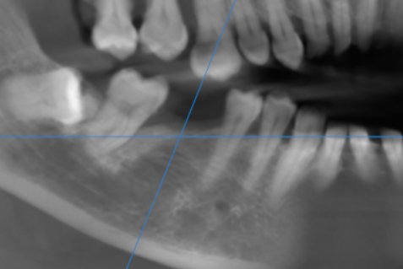

3-DIMENSIONAL VIEW

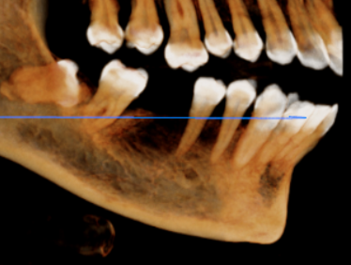

CROSS SECTIONAL VIEW

46 region | 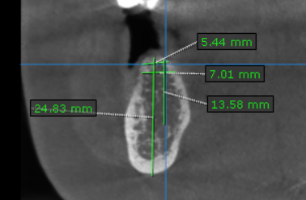

**** End of report ****

